How to login the Linux instance wia putty app -

* Go to AWS Console – ***EC2 Instance*** – Launch the new instance (Linux)

* Now Go to Connect option – Check the instance login – Login with *ec2-user(default)*

* Now we can convert the private key from .**pem to .ppk**
* Go to **Puttygen** & click on load the file option

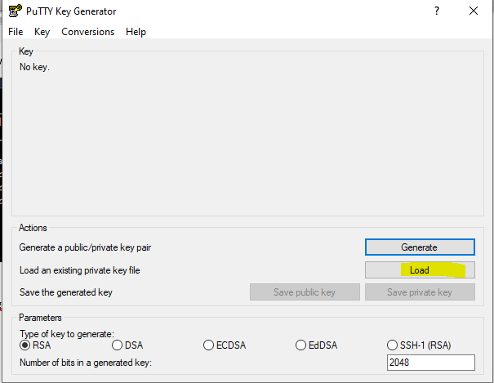

* Save the .ppk file in secure place

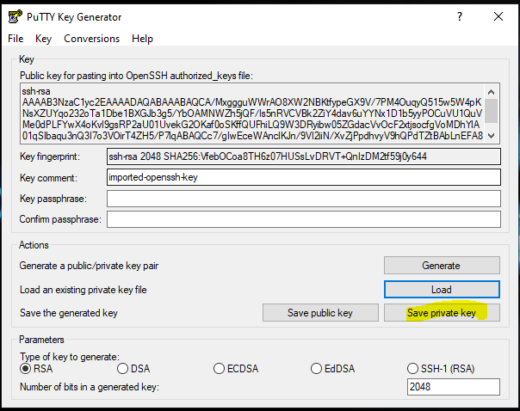

* File has been saved in key folder -.ppk
* Now we can access Linux instance from the putty-
* No go Instance & Open the instance from the console Tab

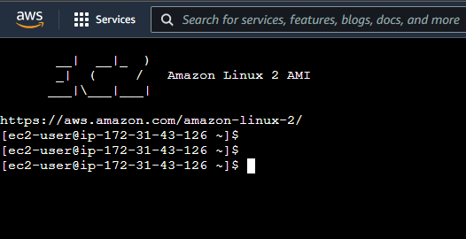

* Now we can check the user details with above command –

cat /etc/passwd Provide the details of profile



* We have provided the details of users -like.
* Username? Host Name? IP address?? User profile details??

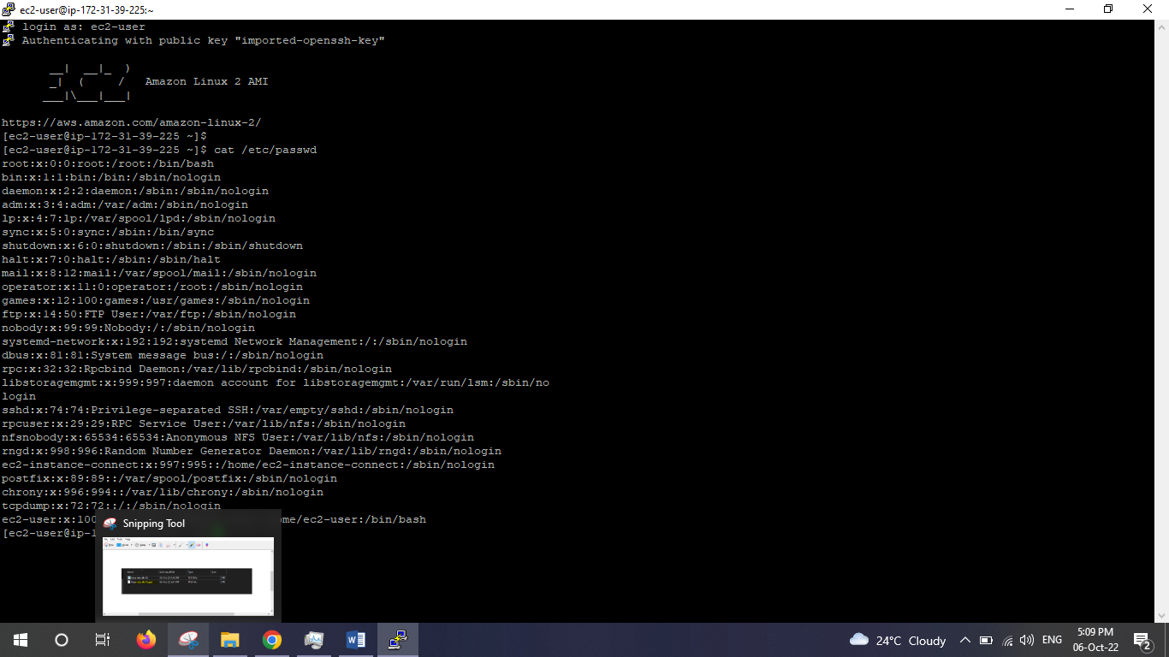

* Now go to puttygen app & create .ppk file for access the Linux Instance from putty app
* Make sure save the private key in secure location & give the name .ppk

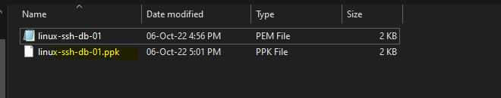

* Now go to Putty app & open the Linux Instance follow below-
* Open the Putty App & provide the public Ip - 43.205.103.37 & give the new .ppk file so you can able to access the Linux Instance from Putty

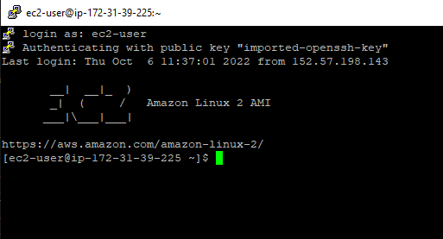

* We can move from ec2-user to root user (its look like administrator) account

sudo –s For switch user

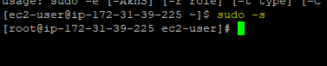

* Now we are in root user – Like admin –so we add users on here –
* We add the raja user with below command

useradd raja For new user add -raja



* How can we check the user login with below command

whoami check the profile login

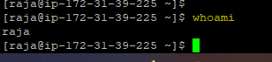

* Set the password for raja

passwd raja set the password for raja

* And confirmed the same as well with enter

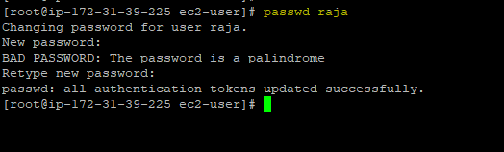

* How to move from root user to raja –with below command

su – raja switch user

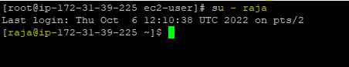

* Now we need to check the details from the file

ll –a Details in directory

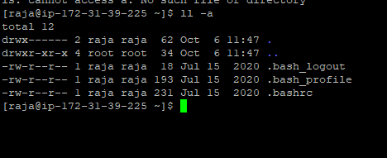

* Single dot _______shows current Directory (.blue dot)
* Double dot_______Shows parrent Directory (..blue dot)

----This all are profile files----

* Now we need to create the .ssh file in raja , so can use the below commands

pwd – for Directory checks

mkdir .ssh create the ssh in directory

ll –a view the files in folder (raja)

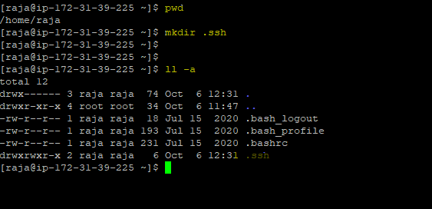

* If any hidden fil in directory we can user the below command

ls –a hidden file check

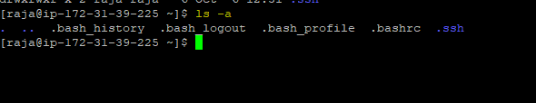

* Now we need to change the permission for .ssh folder

Chmod 700 .ssh Change the permission

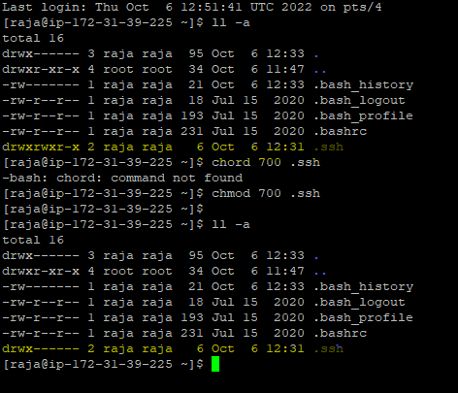

* Now we need the authrized key file so we need to go root user so we exit this & switch to root user for now

exit go to root user

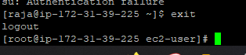

* Now we can go to root user & copy the authorized_keys file from root user to raja

**cp /home/ec2-user/.ssh/authorized _keys /home/raja/ .ssh**

**chown raja:raja /home/raja/.ssh/authorized_keys**

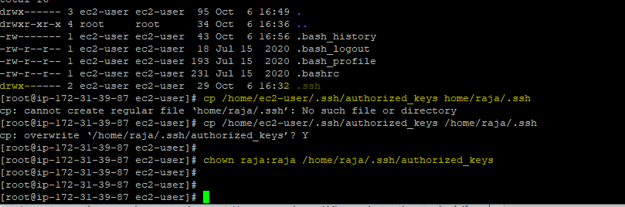

* Exit the ec2-user instance & Open the new putty app & try to login with raja

Now We can login with **raja** –

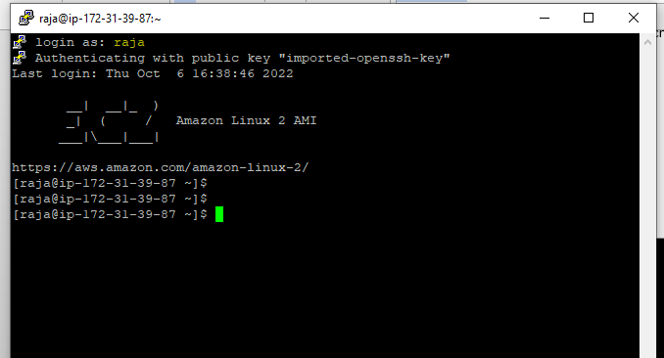

\*\*\*\*\*\*\*\*\*\*\*\*\*\*\*\*\*\*\*\*\***END**\*\*\*\*\*\*\*\*\*\*\*\*\*\*\*\*\*\*\*\*

How to add other users in same instance :-

* Open the instance & switch ***ec2-user*** to root user
* Now add the **rani** user with below command

adduser rani new user adding

* Now we check the user add in below command as

Cat /ect/passwd

* Now we can set the password for rani

Passwd rani

* Now We create the .ssh file for rani

su -rani

pwd

ll -a

mkdir .ssh

ll -a

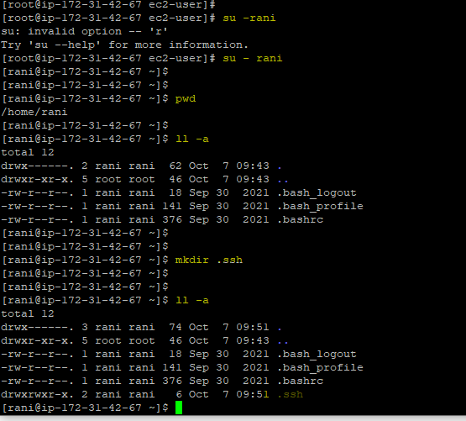

* Now we need to give the authorized keys-
* Now we can go to root user & copy the authorized_keys file from root user to raja
* **cp /home/ec2-user/.ssh/authorized _keys /home/rani/ .ssh**
* **chown rani:rani /home/rani/.ssh/authorized_keys**

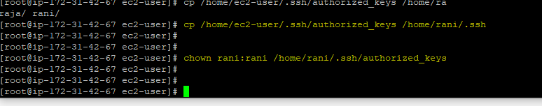

* Exit the ec2-user instance & Open the new putty app & try to login with rani
* Now We can login wth **rani**

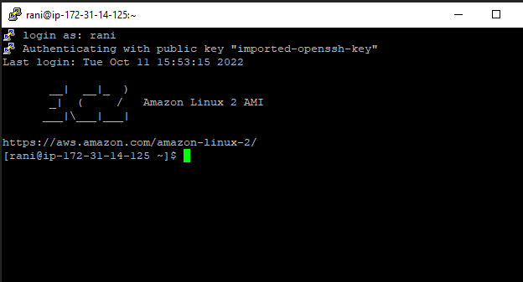

* Now We can login with **raja**

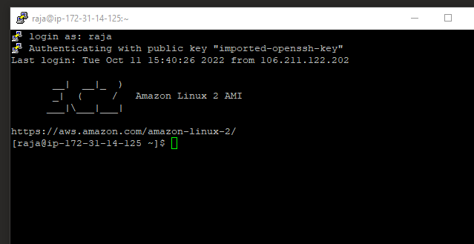

* Now We can login with **ec2-user**

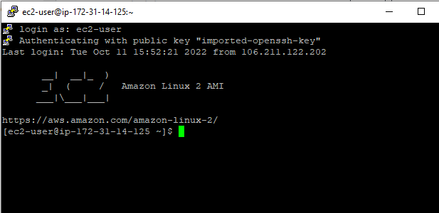

\*\*\*\*\*\*\*\*\*\*\***END**\*\*\*\*\*\*\*\*\*\*\*\*\*\*\*\*

